Lab Practical #8:
Study & Survey of Institute organization network infrastructure.
Practical Assignment #8:
- Identify type of network in your institute. Draw a design of network in your institute (Any Lab/Floor/Building).
Lab No: C- 306
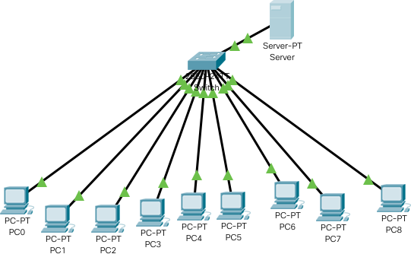
Topology: Star Topology

- List how many network devices and types of cable used and give its details.

Networking Devices :
- Switch
- Connects many devices in the same network, like PCs and printers.
- Sends data only to the device it is meant for, not to everyone.
- Router
- Joins two or more networks together, like your home network and the internet.
- Chooses the best path for data to travel from one place to another.
- Firewall
- the network by blocking unwanted or unsafe traffic.
- Works based on rules set by the network administrator.
- Network Interface Card (NIC)
- A hardware component that allows a computer or device to connect to a network.
- Can be wired (Ethernet) or wireless (Wi-Fi).
- Access Point (AP)
- Wi-Fi so that wireless devices can join the network.
- back to a wired network to give internet access.
- Load Balancer
- the network traffic across different servers.
- Helps improve speed, availability, and reliability of services.
- Modem
- digital signals to analog (and back) so devices can access the internet.
- Works with telephone lines, cable lines, or fiber.
Types of Network Cables:
- Fiber Optic Cable
- Transfers data using light signals, which makes it very fast.
- Can send information over long distances without losing quality.
- Ethernet Cable (Cat5e, Cat6, Cat6a)
- Most common cable used for wired connections.
- Made of twisted pairs that reduce noise and support high speed.
- Console Cable (RJ45 to Serial)
- Special cable used for configuring routers and switches.
- Connects a network device directly to a computer.
- Coaxial Cable
- Older type of cable that carries data with electrical signals.
- Still used in some TV and internet connections.

